Installing WRSAFS

By

John Crunk

The Install Process 3
Install Troubleshooting 3
Appendix A 5

Purpose

The purpose of this document is to walk the user through the process of installing WinRunner Software Automation Framework Support (WRSAFS). Every effort has been made to make this process as simple and painless as possible, but there are occasions where some things were not taken into account. It is hoped that an explaination of some of the process involved in the install process will allow the user to be able to run down any potential problems.

The Install Process

The install process consists of a single install file that contains all of the components necessary for installing WRSAFS. To install, all you must do is simply follow the following steps:

- Backup any prior installs and uninstall
  - VERY important, all customizations will be overwritten without prompting.
- Install Java Virtual Machine (JVM) from http://java.sun.com/j2se/
- Verify that cscript is version 5.6 by going to a command prompt and typing cscript. If it is not, download and install from http://msdn.microsoft.com/downloads/list/webdev.asp
- Download and RRAFS, extract to a temp folder, and run Setup.vbs, this doesn’t mean you are installing RRAFS, you are just installing STAF and SAFS from this setup.
- Run the WRSAFS Install
- Scripts are installed to C:\WRSAFS
- Test Tables are installed to C:\Datapool
- Verify C:\\STAF;C:\\SAFS;C:\\STAF\\Bin is added to the path
- Verify the following Classpath additions have been made for STAF and SAFS jar files

C:\\STAF\\bin\\JSTAF.jar;C:\\SAFS -staf C:\\STAF\\lib\\jakarta-regexp-1.3.jar;C:\\SAFS -staf C:\\STAF\\lib\\SAFSCUST.jar;C:\\SAFS -staf C:\\STAF\\lib\\SAFS.jar

- Verify registry entries have been made and are pointed to the correct directories

Once the install is completed, you should visit the SAFSDEV site at http://sourceforge.net/projects/safsdev and select list. The name of the list you will need to join for the WRSAFS is safsdev-wrafs-archives. On this list you may post problems you have had with WRSAFS, enhancements you would like to see or general help issues. The developers of this engine will respond with possible solutions to your problems. You may also find it helpful to join the list for RRAFS, while this engine is not exactly the same, the use and most of the functions are.

WinRunner Settings

To make the engine work correctly there are some settings that must be changed to allow the scripts to run a fast as possible and recover from some of the problems that may occur. Below are screen shots of the settings that must be changed to make the scripts work, please make sure that all setting are exactly as specified in the screen shots below:

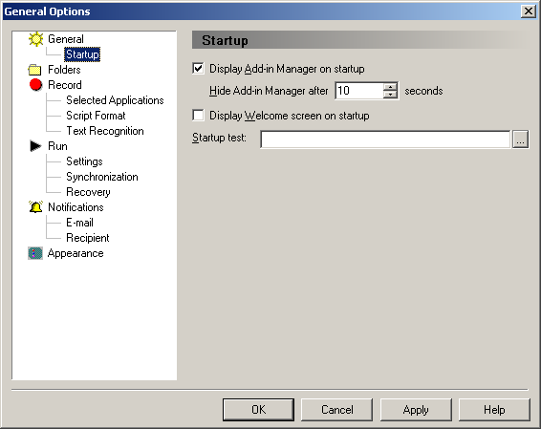
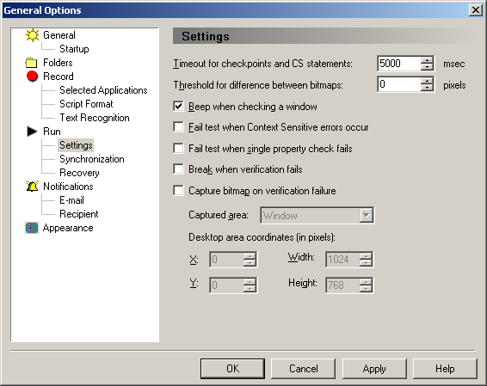

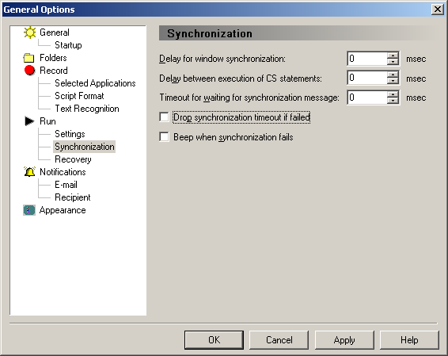

Install Troubleshooting

While every attempt has been made to make sure that there are not any problems in the install, they are bound to happen. When errors do occur, you will find that the engine doesn’t run correctly and that user intervention is required. The following steps can be taken to solve most problems that can occur.

Verify the path includes c:\staf;c:\safs;c:\staf\bin
- Verify the following keys are added to HKEY_LOCAL_MACHINE and HKEY_LOCAL_USER
  - Under Software/WRSAFS
    - EnginePath=C:\WRSAFS
    - CyclePath=Cycle
    - SuitePath=Suite
    - StepPath=Step
- Verify the DDVariableStore.dll is registered correctly using the following steps
  - Select Start then run
  - Type regsvr32 –u “c:\Program Files\Mercury Interactive\arch\DDVariableStore.dll”
  - Type regsvr32 “c:\Program Files\Mercury Interactive\arch\DDVariableStore.dll”
  - If this still doesn’t fix the problem, verify that RRAFS is not causing a conflict by unregistering the DLL in its default directory and registering only one.
- Verify that the Java Virtual Machine is install by going to http://java.sun.com/j2se/

Some changes require rebooting, try this if you are having problems and have tried everything else even if you believe you should not have to there is nothing like a good reboot to get the machine going again.

